How to create a DevOps Project on BlueMix

Exercise: Create a project on IBM BlueMix, push code to BlueMix and configure Build&Deploy as well as Track&Plan features of this project

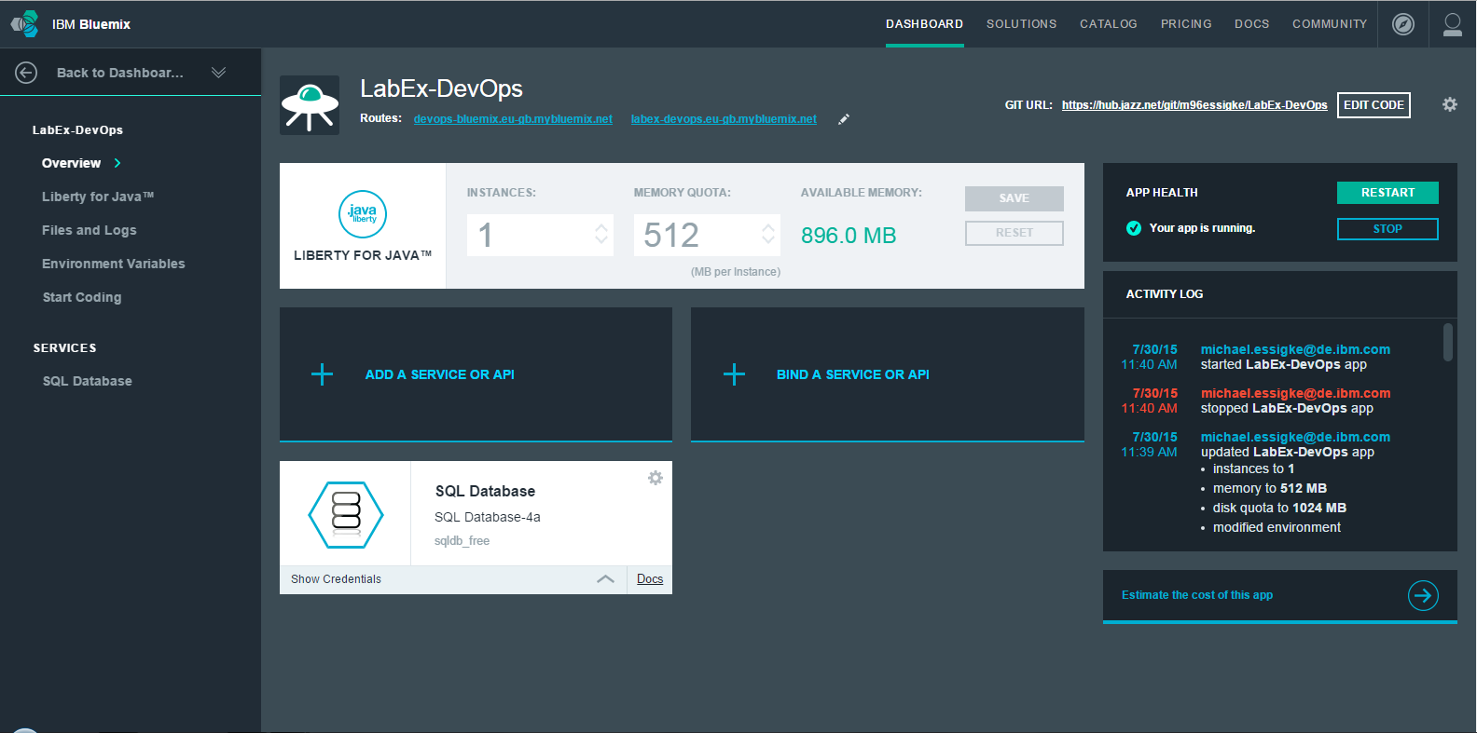

After finishing this exercise you should be able to

- Create a project on IBM Bluemix DevOps Services
- Deploy code to it
- Configure Build, Test and Deploy Stages
- Configure Track&Plan features for the project to keep track of the work that is to be done
  - Create Sprints
  - Add work items to these Sprints
  - Assign work items to team members
  - Track the current state of the work done in a sprint
- Delete the project if no longer needed

Also there is some additional information on the “Bluemix Live Sync” function which provides the option to quickly update a Node.js application without redeploying to Bluemix

Project Creation on IBM BlueMix:
In this exercise we will create a project on IBM BlueMix DevOps Services. For this an account on https://hub.jazz.net is needed.
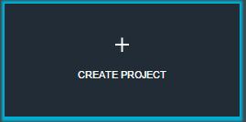
After logging in we need to go to the “My Projects” tab in DevOps Services and click the “Create Project” Button.

Now we give the project a name and create a new Git repository on Bluemix
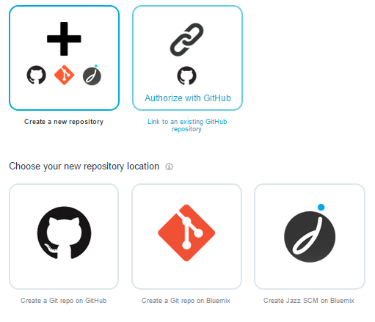
For the Project planning features that we will need later we have to check the box „Add Features for Scrum development“ as well as we need to check the box „Make this a Bluemix Project“ to be able to deploy code to BlueMix later.

The project is now being created and we can add code to it. The overview page of the project provides us with the link we need to add code to the git repository.
If you have git installed we can add the code via the git command line now

Open the command line and navigate to the directory where you want your code to be saved.
git clone --no-checkout $Your_URL
cd $Your_Dir

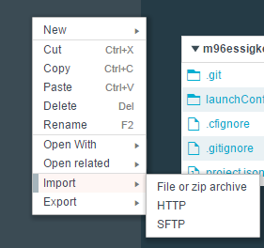
Copy the code that is attached to this exercise there and push the code using:
git add .
git commit -m "first commit"
git push -u origin master

You can also upload your code using the web editor interface of BlueMix. To do so click on the “Edit Code” Tab and to a right click on the left panel with the file system hierarchy.

Build and Deploy on BlueMix:
After we uploaded the sample code we can now configure the Build and Deployment of our sample code to get it running on BlueMix.

For this you need to click on the button “Build and Deploy” in the upper right corner of the DevOps Services web interface.


Let’s first add a stage for building the code:


There are different jobs that may be configured for each stage. 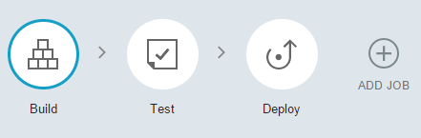
We usually need a build job in the build stage and a deploy job in the deploy stage. If we want to add some testing we can also configure a test job if we want to.

The build job:
DevOps services offers the option to automatically build the project, that means if it is configured correctly, it automatically manages the dependencies, compiles sources and creates e.g. a .war file for a WebApplication.
The build job offers different options on which tools may be used to build the project. Common options are for instance “ANT”, “maven”, “gradle” or “npm”. If one wants to use one of those automated build tools, one has to configure the build process. In this exercise we will use ANT so we need to configure a build.xml file. If for example maven is used, one needs to configure a pom.xml file to define how DevOps services should build the project.

The test job:
In some projects we may want to add some automated testing, this is when we can use the test job. IBM offers some automated testing tools which can be included in this job. Here is a short description for every possible option (at the time of writing the document).
Simple: A basic tester that invokes a shell command to run the automated tests, with an optional test report.
IBM Security Static Analyzer: Run a static security code scan by using the IBM Security Static Analyzer on Bluemix
IBM Vulnerability Advisor: Run compliance and vulnerability checks against a pushed docker container image.
Sauce Labs: Executes Javascript/Node or Java tests using Sauce Labs.

The deploy job:
Finally we have the deploy job which is used to push the application from the SCM repository to BlueMix (or any other CloudFoundry instance).
We can define on which server, at which organisation and on which space the application is to be pushed but usually we do not have to configure this job as the standard settings should work.
For correctly deploying to Bluemix we should create a manifest.yml file. We will do this when we configure the Deploy stage.

Configure the build stage:
Now we want to configure our own build stage. Please click on “Add Stage”.
As an input we want to select our Git Master Branch and as a type the „SCM Repository“.
After this, we need to create a Build Job, which needs to be configured using “Ant” as Builder Type for our project

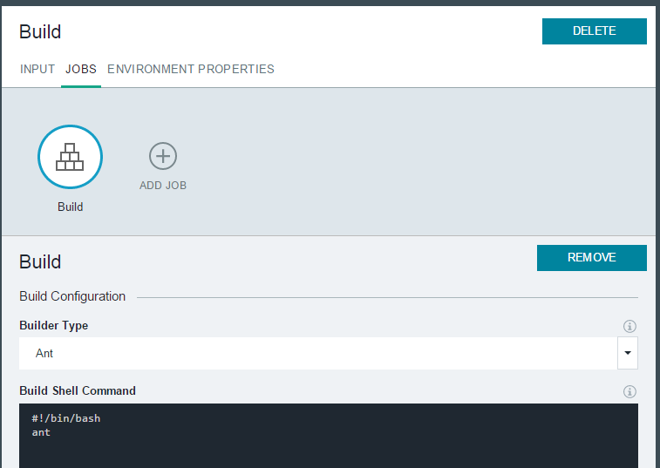

This Stage will build the our code, so that we can use its output as input for our next stage, which is the deployment stage.

Befor we add the deployment stage we should create a manifest.yml file which is used for configuration of the Bluemix app.
Herefore you can use the following code and adapt it to your requirements.
applications:
- disk_quota: 1024M
host: %Your_Host_Name% (e.g. myApp)
name: %Your_App_Name% (e.g. myApp)
path: %Path to the executable file that is created in the build stage% (e.g. myApp.war)
domain: eu-gb.mybluemix.net (or ng.mybluemix.net)
instances: 1
memory: 512M
buildpack: liberty-for-java (or any other buildpack)
You can save this code to a “manifest.yml” file on the top level of your source code directory. But make sure that it is copied with the build artefacts to the target folder. Either configure the build file or change the build script accordingly
cp manifest.yml target/manifest.yml
if the build archive directory is “target” (which is the default value).

For configuring the deployment stage we add another stage but change the input type to “build artefacts” and create a “Deployment” Job.
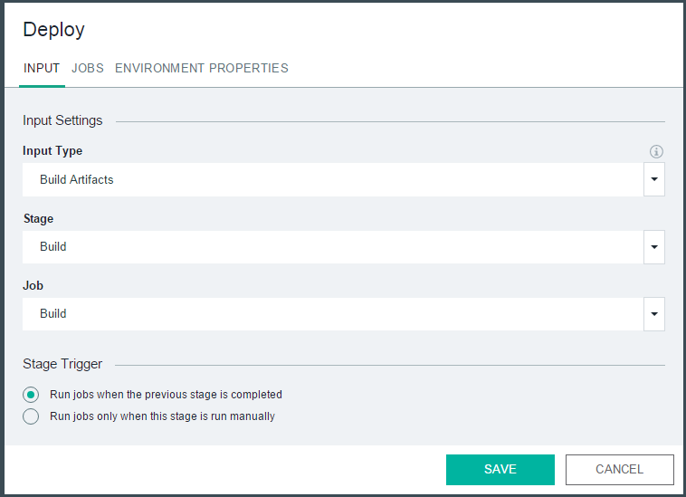

The Build and Deploy phases should automatically run, if not, just press on the “run” icon on the top right corner of the Build Phase.
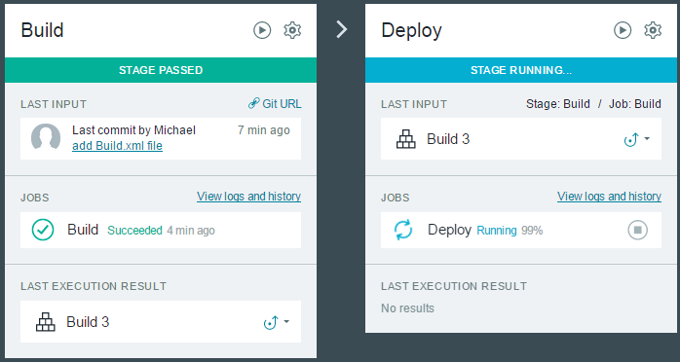

If the build.xml and Manifest.yml files are set up correctly BlueMix will automatically choose the required runtime environment (which is Java Liberty in this case) and the build and deploy processes can be completed without any problems.

Adding a service to an BlueMix project:
We now will add a service to our BlueMix project. For example some sample code may require the usage of a SQL DB to work.
Herefore we need to add a SQL Service to our BlueMix project, Edit the config.properties file with the new connection details and upload/build/deploy this to BlueMix again.

Firstly we add the service to our BlueMix project:
Please open https://bluemix.net, and login.

Click on the solution tab and scroll down until you find the service “SQL Database”.
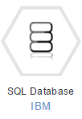
After clicking on it we get redirected to a page where we can create and bind the service to our application.
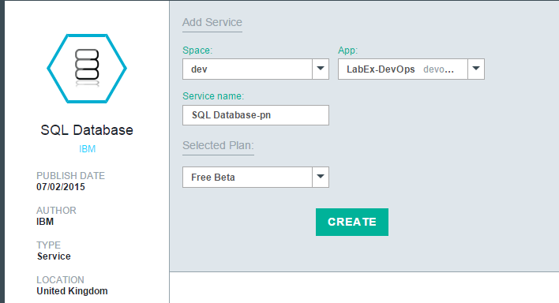

When we created it and navigated back to the dashboard the service is listed under services. Click now on the sample project we created. You can see that the service “SQL Database” is bound to our application. Click on “Show credentials to see how to access the database.

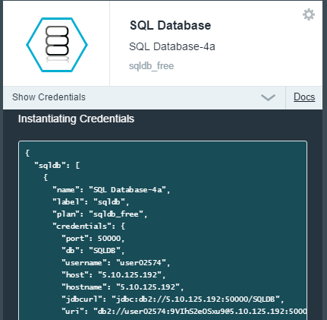

Now we need to edit the scheme of the database.
To do so navigate to the project dashboard on BlueMix and click on the SQL Database Frame. You will get redirected to a frame where you can click a “launch” button.
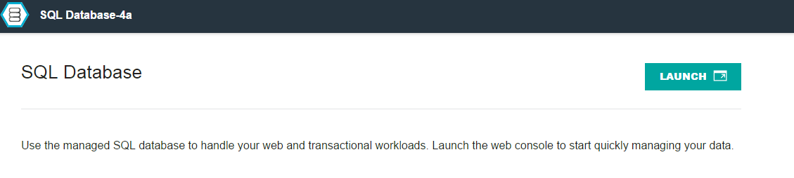

You need to click on work with tables
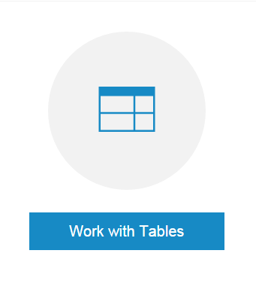
to add the SQL schema for our application.
Now add the SQL tables to the database schema.


By clicking on the (+) Icon we can add DDL (data definition language) SQL code to set up the tables we need in our application.

Automated Testing
Now we have a running application deployed on IBM BlueMix. Developers can now go on making changes to the code on the Git Master Branch that are automatically built and deployed to the BlueMix Server. We can add automated testing as well if we want to by adding a custom testing job or phase before deployment. If a phase fails, we can take a look at the log file by clicking on the “view logs and history” link in the job description.

The way how one can set up some automated testing varies deeply on the kind of application, the build tool and testing framework that one uses.
For example if one is using ANT and JUnit one can create a custom junit-testing job in the ANT build.xml file and run this job with the command “build junit-testing” during the testing job. Besides custom automated testing also the automated testing tools can be used that were described in the “test job” section.
In the following section I want to describe how to add a sample testing class to a project. We will use ANT and JUnit for this testing.
Adding testing functionality basically contains 4 steps for us:
- Add the required libs to the project
  - We require two additional libraries to add junit testing.
The junit-4.12.jar and hamcrest-core-1.3.jar. Both can be downloaded here: https://github.com/junit-team/junit/wiki/Download-and-Install
Download them and add them to the project folder. If you want to use the code below, you need to add them to the folder “dep-jar”.
- Add the testing class
  - We need to create the class that we want to test: For explanatory purpose I created the most simple test class just to show how testing basically works. Create a new java class Testing.java in the source folder of your project and add for example the following code
package ---!!! DEFINE YOUR PACKAGE HERE!!!;

import static org.junit.Assert.*;
import org.junit.Test;

public class Testing{

@Test
public void testWillReturnTrue() {
// assert statements
assertTrue("Test okay", true);
}
}
- Change the build.xml to support the testing
  - The build.xml needs a target which we can use to run our test job. Sample code would be this:
<path id="classpathDir">
<pathelement location="dep-jar/com.ibm.ws.javaee.jaxrs.1.1_1.0.1.jar"/>
<pathelement location="dep-jar/junit-4.12.jar"/>
<pathelement location="dep-jar/hamcrest-core-1.3.jar"/>
</path>

<target name="junit">
<mkdir dir="tests" /> <!—We will save the compiled sources temporally here -->

<javac debug="true" destdir="tests" source=”1.5" target=”1.5” includeantruntime="false">
<src path="src"/>
<classpath refid="classpathDir"/>
</javac>

<junit printsummary="yes" haltonfailure="no">
<!-- Project classpath, must include junit.jar -->
<classpath refid="classpathDir" />
<!-- test class – you need to define the class that you want to test here -->
<test name="----YOUR PACKAGE---.Testing" haltonfailure="yes" todir="tests">
<formatter type="xml" />
</test>
</junit>

</target>
- Configure the test stage in the deployment pipeline
  - After we defined the code, we need to push it to bluemix and to configure the test stage. Push the code via GIT and then click on “Build&Deploy”.
First, click on “Add new Stage”, give the stage a name (e.g. “Test”) and change the input type to SCM Repository. Then add a test job. We will use the “simple” tester type and our test script only needs the command “ant junit”. Finally check the box at “Enable test report”.
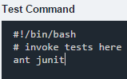
We save the script and let it run. It should succeed with no errors. If we check the log, we should be able to see a test report.
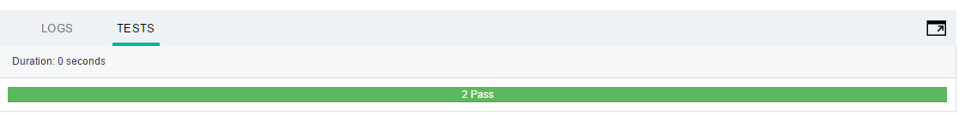

For a project one can also add some sample integration testing
To support integration testing, BlueMix offers an experimental service (at the time that you read the document, the service may already be published). To add an instance to the project please navigate to the Bluemix Services page: https://console.ng.bluemix.net/catalog/
You should either find the service in the “DevOps” or “Integration” section or, if not yet released, in the experimental section down at the buttom of the page:
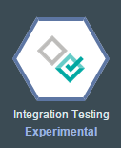
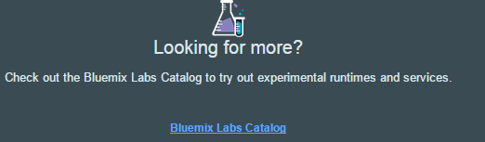
Then locate the service in the „DevOps“ section.
Here you can find a complete example on how to deploy and implement the integration testing service.
https://developer.ibm.com/testing/docs/getting-started-product/

Bluemix Live Sync
For development or debugging it may be inefficient if one needs to redeploy his application over and over for every code change. When developing a Java application with liberty there are the Eclipse Tools for Bluemix which help with debugging. If one is developing a Node.js application, IBM Bluemix provides a different option to ease this process by enabling live changes to the running application just as one does local.
With Live Sync one can synchronize any desktop directory tree similar to IBM Box or Dropbox. To use it one needs to download the BL command line interface.
For Windows 7 and higher: http://livesyncdownload.ng.bluemix.net/downloads/blive_setup.msi
For Mac OSX: http://livesyncdownload.ng.bluemix.net/downloads/BluemixLive.pkg
An app can be set into Live Edit mode which means that changes to the local directory are propagated to the app’s file system immediately.
Also one can use a shell to debug the application while in Live Edit mode. It provides the option to edit code dynamically, insert breakpoints, restart the runtime etc.
After downloading the BL CLI and installing it one can sync the available projects with Bluemix.
- open a CMD and type “bl login”
- view the list of available projects “bl projects”
- Sync the local environment “bl sync projectname –d localDirectory –verbose
- Open another CMD window in the local directory and deploy the app to Bluemix in live edit mode by typing “bl start”. If the Node app needs to be restarted type “bl start --restart”

Further information on how IBM Bluemix Live Sync works and for some information on how debugging features can be used, you can refer to this page: https://www.ng.bluemix.net/docs/manageapps/bluemixlive.html

Set up the DevOps Services Project:

The next important step for our project is to track and plan the project work. For doing this we can use the built-in “track and plan” features of IBM Bluemix DevOps Services. Just click on the “Track & Plan” Tab and enable the features in the “Project Settings”

Check the “Enable Track and Plan” Box and then click the Save Button
On the left hand side one can now see different options for planning the work that is to be done by the team.
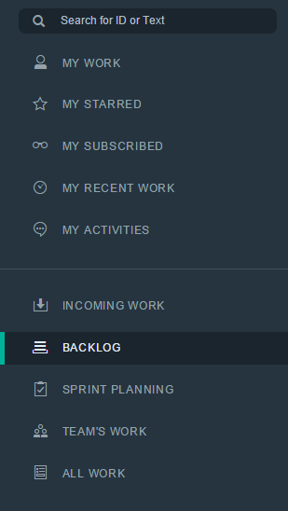
We can start the project planning with adding some tasks to the Projects Backlog. Click on the “Backlog” item on the left menu bar first.
We easily add a new work item by clicking on the “Create a work item” Field
Let’s get started with a new Story Item:
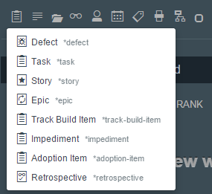

We file it against the current project, but we won’t assign a team member to work on it right now. As we’re working agile, this will happen only when we decide to implement it during a sprint.
We then can add some tags, story points and other metadata as well as a title for this story.

The story now appears in the project backlog
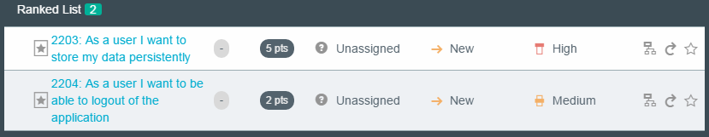

After creating User Stories, we can add tasks to these stories by creating work Items of type task and assign a parent to them.
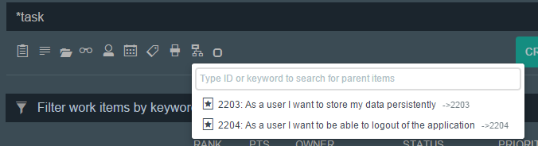

In the ranked list of the backlog we now can see that the Story 2203 has two tasks assigned
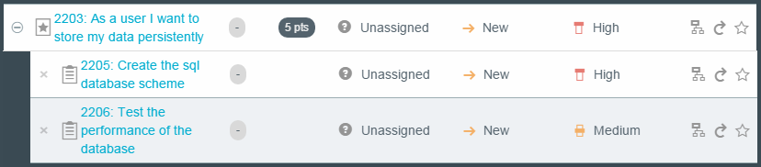

You can go on creating other tasks and stories for the project but for now we want to have a look on how the sprint planning works. Please click the “Sprint Planning” Tab on the right side of the window.
Firstly we need to add sprints to our project, you can click the “Add Sprints” Button
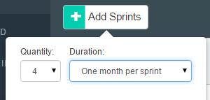

Sprint 1 will start immediately, but if we want to change the start dates we just need to click the „Edit Sprints“ Button. We can use this button as well if we need more than the standard four sprints because it provides the possibility to add sprints.

Now that we have created multiple Sprints for our project we need to decide which user stories should be implemented in the first one. For our sample purpose we just use the first story we created and assign it to the first sprint.

BlueMix DevOps Services provides us the functionality to use Drag&Drop to move one Workitem to a Sprint, so we will just drag the user story we created before and drop it in the “Sprint 1” Field.
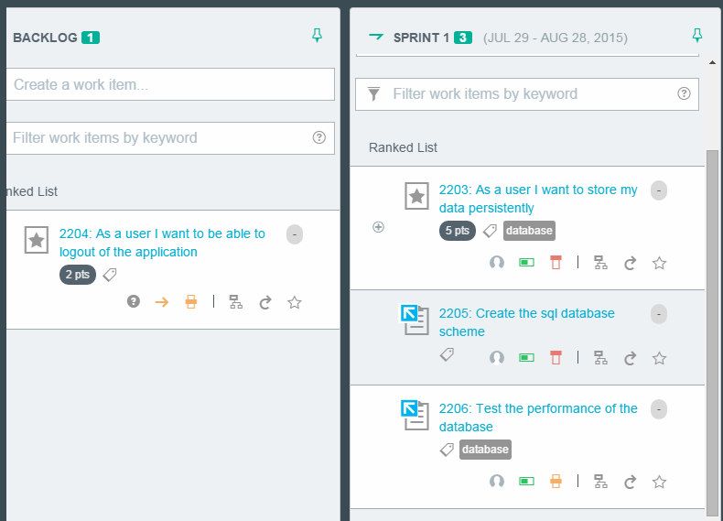

We also can directly create new work items for every sprint by using the „Create a work item“ text field in each sprints window.

Next step is to assign stories or tasks to team members which we do by clicking the little questionmark item.
We can also change the status of the story to „Start working“ now by clicking the little yellow arrow next to the question mark.
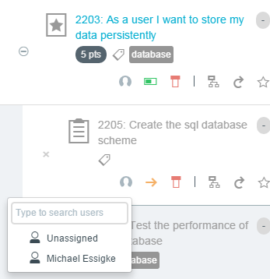

After assigning an item, the assigned user will receive an email with a notification that this item has been assigned to him.
Every user can see the assigned work by using the “My Work” Tab and switching between the “Open” and the “In Progress” Tasks.
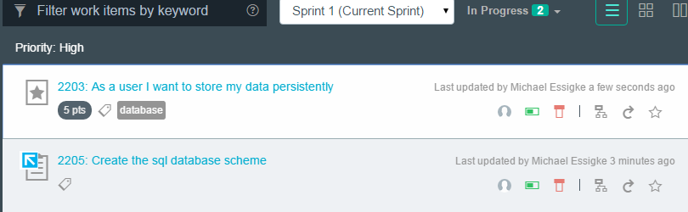

By clicking on the work item link we can also easily add other options e.g. the time remaining to finish this work product
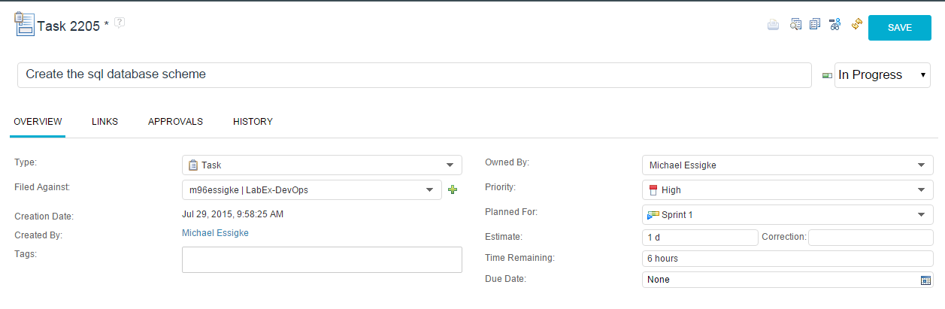
This can also be done directly by adding an estimation to any task item
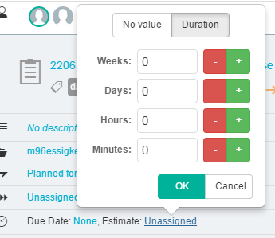

After having added some time estimations or having updated the time needed to complete the task we can track the team progress in this sprint.
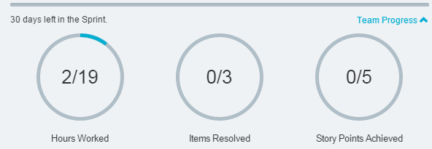

If we want to find a work item we can use the built-in search function of DevOps Services
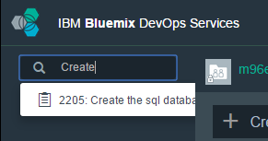

People who worked with RTC as a project planning tool might miss some features for directly querying all of the work items. However, we can easiliy to this by creating custom views. Let’s creat one to list all of the story itmes that are in progress with high priority.
Firstly, click on the “All Work” Tab

When we click “Save” we can save this query to the custom views so that we can easily reuse the query at a later point in time. If this query is very important for other team members as well we can share it with others by clicking the small arrow that appears when hovering it


People who are used to working with the RTC for project planning can still use the web environment of the RTC if it is really necessary. The dashboard is available by clicking the arrow next to the “Track&Plan” Tab
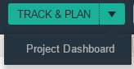
This dashboard provides the graphical representation of the current status of the sprint by showing Sprint Burndown Charts and other information.
It can also be used for the typical RTC operations for querying work itmes or creating/editing the project plans/backlog. To get back to the DevOps Services view just click on the“Track&Plan” Tab again.

Delete a project on DevOps
To delete a project on DevOps go to the Settings page (next to the Build&Deploy Pipeline icon)


On the left site of this window now you can find the option.
You have to type in “DELETE” and then confirm to delete the DevOps project
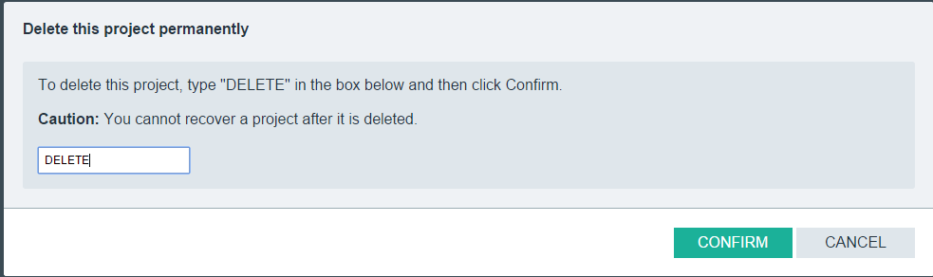

Now you learned how to monitor and plan team activities for an agile software project on the IBM product IBM BlueMix DevOps Services.

Resources:

BlueMix Documentation
http://www.ng.bluemix.net/docs/

SQL Service
http://www.ng.bluemix.net/docs/#services/SQLDB/index.html#SQLDB

Code

